|  |  |  |
| --- | --- | --- |
| Cairo University  Faculty of Engineering  Computer Engineering Department | | ­­­­CMPN450  Fall 2018 |
|  | **Pattern Recognition and Neural Networks.**  Lab 2 – Classification Methods |  |

In this lab, it is required to identify between different hand-drawn shapes; such as rectangles, circles, triangles, ellipses, polygons, etc.

We will start our first lab in this course by understanding the main pipeline of any machine learning project:

A ML project is divided into many stages:

1. **Gathering Data:** The first real step of machine learning is gathering data. This step is very important because the quality and quantity of data that you gather will directly determine how good your predictive model can be. In this case, the data we collect will be the images of hand-drawn shapes.

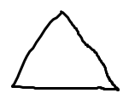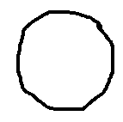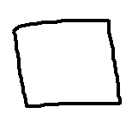

A rectangle A circle A triangle

1. **Data Preparation:** In this stage, we need to convert the raw data into a clean data set. In other words, whenever the data is gathered from different sources it is collected in raw format which is not feasible for the analysis. In our case, we need to convert our RGB images to grayscale, smooth them to remove noise by applying a Gaussian filter or a low pass filter (blurring), and applying a threshold on the image pixels. The pixels having intensity less than this threshold should be considered black pixels, and white otherwise.
2. **Feature Extraction**: This step could be either:
   1. **Feature Engineering:** transformation of raw data into features suitable for modeling.
   2. **Feature Transformation:** transformation of data to improve the accuracy of the algorithm.
   3. **Feature Selection:** removing unnecessary features.

The process of feature extraction in our problem can have many designs:

* One design is to extract the number of black pixels compared to the number white pixels in each image and use this feature to differentiate between different shapes. (Is this a powerful feature?) Can you think of other features?
* We will extract features by computing the convex hull of these shapes, and compare this convex hull with the minimum enclosing circle, minimum enclosing rectangle and minimum enclosing triangle bounding that figure.

* In this example, the ratio between the areas of the convex hull (figure) to the area of the bounding triangle will be maximum, and relatively smaller for the bounding rectangle and circle respectively. On the other hand, if the given shape was a circle, then the ratio between the areas of the shape to the bounding circle will be maximum and smaller for the bounding rectangle and triangle.

Therefore, each image will be represented with a feature vector in three-dimensions (x, y and z) where each component represents the ratio between the area of the figure to the area of the bounding rectangle, circle and triangle respectively.

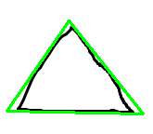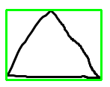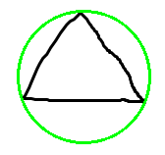This image can be represented as a feature vector (0.67, 0.58, 0.92)

1. **Model Selection:** It’s time to feed the crafted features to the classification algorithm that is going to classify or predict the class of unknown or newly unseen data (called testing data). The process of choosing which classification algorithm will yield the best results is not an easy one. It is often subject to many iterations of tuning parameters and features.

In our case, we will apply three classification algorithms and compare their results:

* 1. Minimum Distance Classifier.
  2. Nearest Neighbour Classifier.
  3. K-Nearest Neighbour Classifier.

1. **Performance Results:** After training the classifier with the training data, it’s time to test its accuracy against testing data (i.e. data that is unseen or new for the classification algorithm). The accuracy is reported as the percentage of the number of instances that were correctly classified to the total number of instances.